Website Finishing Touches

* CSS Padding (cuts off on top and logo gets distorted)
* Employee leasing/peo page
* Payroll processing page
* Workers comp page
* Benefits page
* Fix about us page
* Put icon on reviews to go to next one and take out “company name”

Home Page To do

1. CSS Padding
2. Make our services a drop down list with these pages ( PEO/Employee Leasing, Payroll Processing, Worker’s Compensation, Employee Benefits)
3. Bold/black and hyperlink number at bottom forum
4. Remove Company name under the reviews
5. Add some sort of thing that indicates you should click next on reviews
6. Make sure number is always visible on mobile

About Us To do

1. Turn into just an about us page
2. Put in image that I have taken (use this for filler)
3. Below is the way the page should be formatted w texts

**About Us**

Our Mission: “We are here to provide highest level of personalized service achievable. We strive to combine this extreme attention to clients’ needs with our time & money saving business model to provide a unique and essential service to any small business”

*make this above part look cool*

Our Story:

The Professional Employer Organization industry is dominated by larger players and the barriers to entry are high. We knew this when we started AllianceHR and determined that we needed to be different so that we can provide value and succeed in the space.

The biggest problem most people have when using a PEO is the lack of personality and care, usually from larger companies with that simply just don’t understand how real people work. We devised a service first model that ensures that we provide an exceptional level of care and quality. Each of our clients has a dedicated payroll processor and access to the rest of the AllianceHR team at all times.

“Every time you call AllianceHR you are immediately connected to a real person who has the power to solve the problems you are facing, and that’s something you can’t find anywhere else.” – Arthur Scott *Co-Owner & General Manager*

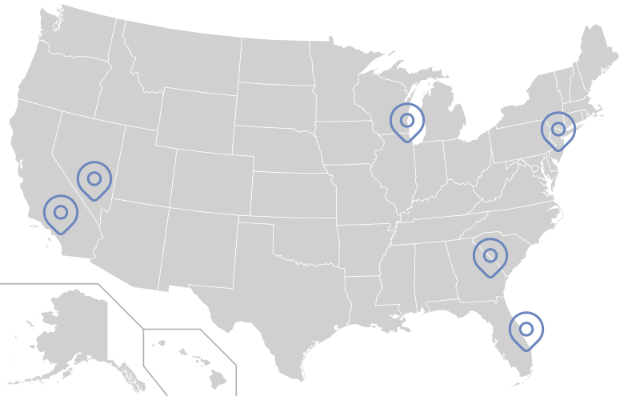This has proven highly valuable to the market as our business continues to attract clients who are both new to using a PEO and experienced with the PEO model. As we look towards the future, we have plans to increase the level of care we provide and increase the availability of our service into additional states. Currently we service clients in six states: Florida, Georgia, Illinois, New Jersey, Nevada, and California.

If you are interested in partnering with AllianceHR please give us a call at 561-972-4449 so we can discuss the future of your business today.

**PEO/Employee Leasing Page**

**What is a PEO or Employee Leasing Company**

A Professional Employer Organization(PEO) and Employee Leasing company are full-service human resource outsourcing that operates under a co-employment model. Under this arrangement we provide payroll, worker’s comp, benefits administration, compliance, and much more on the behalf of your business. We have all of the liability when it comes to worker’s comp and payroll since under the co-employment model we can file all wages paid under our FEIN number.

**Why use a PEO?**

With our expert, strategic guidance as your PEO, you will be able to grow your business and have peace of mind that you’re more protected while doing so. We will help you with:

* **Payroll and tax filing**  
  We process payroll and pay local, state and federal employment taxes. Payroll takes no more than a few clicks and we process the rest. We even have integrated systems to track and manage time that syncs directly with our software.
* **Worker’s Compensation Insurance**  
  When you partner with AllianceHR you will be enrolled underneath our master worker’s comp policy. We offer a flat percentage rate for worker’s comp and handle the complicated worker’s comp audits. Learn more on our worker’s comp page!
* **Compliance**  
  Our experts protect your business from fines and penalties in every HR area. We specialize in payroll tax law and reporting requirements, unemployment insurance, worker’s compensation, hiring and HR compliance.
* **Human resource support**  
  You will have a dedicated payroll processor who is familiar with the ins and outs of payroll, worker’s comp, compliance, and more. The rest of our team will also be here to assist you in any HR business related activities.
* **Benefits administration**  
  Our minimal essential coverage & supplemental benefits are available for your employees to enroll in the day you start as a client. We also have strategic partnerships that give you access to major medical plans as well as private insurance.

**Pricing**

Here at AllianceHR we make dealing with HR as easy of a task as it can be. That’s why our pricing model is just as simple. We charge a single flat rate percentage across all payroll ran with us. These rates will vary by size of the business and industry. You can find out more by getting in contact (link to contact page) with a sales representative.

**PEO for your small business**

Small and midsized businesses (1-2000 employees) often turn to us for support and strategic HR management. This allows small businesses to focus more on their core competencies by enhancing the selling of their own products or services. Contact us today to find out more about how AllianceHR can help your small business.

**Worker’s Compensation Page**

**Worker’s Compensation Insurance**

A simple solution to getting your company covered

AllianceHR makes getting covered by “A” rated worker’s comp insurance easy. All our clients are enrolled under our master policy and covered by us. As your professional employer organization (PEO) (link to peo page) we assume all liability for any worker’s comp claims or management. Here are just a few of the things we handle for you:

* Certificates of Insurance
* Claims management
* Year-end audits
* Risk management
* Return to work programs
* Employee safety programs
* All liability for WC payments

**Pricing**

Our pricing at AllianceHR is simple and straightforward so you as a business owner can know exactly what you are paying with ease. We have a **flat percentage** charged on all payrolls ran through each worker’s comp code. For example, if you have a builder who makes $1,000 a week and worker’s comp is 10% under our contract you will pay an additional $100 dollars a week for worker’s comp coverage for this employee. Pretty simple right?

Partnering with us means you’ll **never** have to deal with prepayments, large premiums, or audits ever again.

The percentage charged for worker’s comp depends on three things: size of payroll, line of work, & loss history. Contact us today to get a quote for your business.

**Payroll Processing**

**A payroll solution that is simple and made for real people and real businesses**

Easily run payroll, manage daily HR, and take care of your employees with AllianceHR



**Online Accessibility**

Access for administration & employees through our website

* Online payroll & reports
* Employee data management
* Print check stubs/forms
* Access to W2s

>Learn more (link this to contact us)

**Reporting**

Multiple reporting options for all your needs

* Standard reports
* Custom built reports just for you
* Multiple file outputs
* Reports on demand

>Learn more (link this to contact us)

**Payroll administration**

Streamlined easy to use payroll

* On-time payroll
* Check or Direct Deposit
* Easy to enter hours
* Custom pay periods
* Bonuses & Off Cycle payrolls

>Learn more (link this to contact us)

**Tax Compliance**

We’ll take care of the accounting and pay the taxes for you

* Federal, state, & local tax filings
* Filed under our FEIN
* W2s done automatically
* No need for an accountant when it comes to employees

>Learn more (link this to contact us)

**Employee Benefits Page**

**Employee Benefits**

Gain easy access to benefits through our in-house and partner sponsored plans

While typical insurance agents try to fit all of your coverage into a limited set of products, Alliance works with you to determine your exact business risks and insurance needs. That way you’re not over- or underinsured. Then we evaluate offerings from multiple partners to find the solutions that make the most sense. This ensures every Alliance client has a personalized plan that fits their business.

**Our Plans**

We always strive to find you the best offerings for your business which could include a custom plan. However we have some in-house offering which can be combined in number of ways. See below for our plan options or get in contact with a representative from Alliance today.

**Custom Built Health Plan**

* Partner sponsored
* Major medical coverage
* Private health plans
* Can be combined with other plans

**Minimal Essential Coverage (In-House)**

* Three levels of basic coverage
* Satisfies government health plan requirements
* Can be combined with other plans

**Supplemental Benefits (In-House)**

* Dental
* Vision
* Critical Illness

**Retirement**

* 401k
* Can be combined with other plans

**PEO Ads Landing page (home page but different words & address used for ads)**

The one stop shop for HR = AllianceHR – The PEO Solution

Payroll, workers' comp, benefits, compliance, & more! = Full Service Professional Employer Organization. Payroll, workers' comp, benefits, compliance, & HR outsourcing, & more!

**Employee Leasing Ads Landing page (home page but different words & address used for ads))**

The one stop shop for HR = AllianceHR – The Employee Leasing Solution

Payroll, workers' comp, benefits, compliance, & more! = Full Service Employee Leasing Company. Payroll, workers' comp, benefits, compliance, & HR outsourcing, & more!

(get you free quote at the bottom) = replace PEO in the first sentence with “Employee Leasing”